Google Cloud Generative AI
Project Documentation format
1. Introduction
Project Title:
Explore With AI: Custom Itineraries For Your Next Journey
Team Members:
M Ritheesh — User Interface & AI Integration Developer
Coordinated project activities, integrated Generative AI services from Google Cloud, handled deployment, and ensured overall system functionality.
Trisha T — Project Lead & Prompt Design Specialist
Designed the user interface, structured user interaction flow, and crafted effective prompts to improve AI response quality.
Kamesh Nataraj — Cloud Backend & API Developer
Managed backend services, configured cloud resources, integrated APIs, and handled communication between application components and AI services.
M Bharath — Testing, Evaluation & Documentation Engineer
Performed system testing, evaluated AI outputs, tracked issues, and prepared project reports, screenshots, and demo material
2. Project Overview
Purpose
The project “Explore With AI: Custom Itineraries For Your Next Journey” aims to simplify travel planning by leveraging Generative AI to create personalized travel itineraries based on user preferences. Traditional travel planning requires extensive research on destinations, activities, and schedules. This system automates that process by analyzing user inputs such as destination, duration, and interests to generate structured day-wise plans. The goal is to reduce planning effort, enhance user convenience, and provide intelligent recommendations.
Features
- AI-powered itinerary generation
- Personalized recommendations based on user inputs
- Interactive and user-friendly interface
- Cloud-based scalable processing
- Real-time response generation
- Structured day-wise travel plans
- Flexible destination and trip duration support
3. Architecture
Frontend
The frontend is developed using React to provide an interactive and responsive user interface. It collects user inputs such as destination, number of days, and travel preferences. Components are structured modularly to enhance reusability and maintainability.
Backend
The backend is implemented using Node.js with Express.js. It processes incoming requests, communicates with Generative AI services, and returns structured responses to the frontend. REST APIs are used to manage request handling and data flow.
4. Setup Instructions
Prerequisites
- Node.js installed
- MongoDB installed or cloud instance
- Git installed
- Google Cloud account and API access
- Environment variables configured
Installation
- Clone the repository
- Navigate to client and server directories
- Install dependencies using npm install
- Configure environment variables
- Start MongoDB service
- Launch frontend and backend servers

5. Folder Structure
- components — UI components
- pages — Application views
- services — API communication logic
- assets — Images and styles
- App.py — Main application file
6. Running the Application
Frontend
Navigate to client directory and run:
streamlit run app.py
The application will be accessible via local browser.
7. API Documentation
Generate Itinerary
- Method: POST
- Endpoint: /api/generate
- Parameters: destination, days, interests
- Response: Generated travel plan
8. Authentication
Authentication is implemented using token-based mechanisms. Secure API access ensures that requests are validated before processing. Sessions or tokens manage user access and protect application resources. Role-based controls restrict unauthorized access to backend services.
9. User Interface
The user interface provides a clean layout allowing users to input travel details and view generated itineraries. Visual components display structured responses in readable format. Screenshots or GIFs demonstrating workflow should be included here.
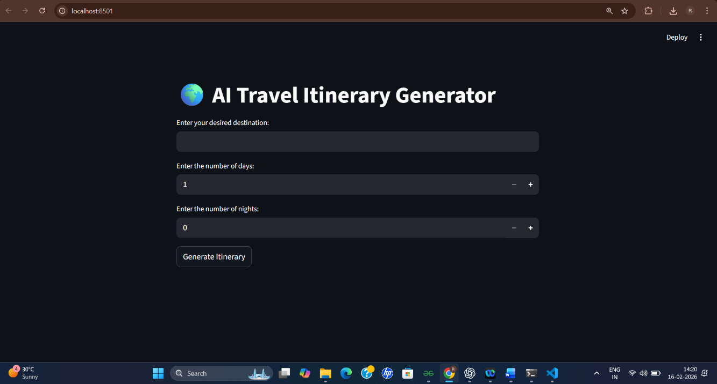
10. Testing
Testing includes functional validation of APIs, UI responsiveness checks, and AI output evaluation. Manual testing ensures correct data flow and response generation. Error scenarios are tested to verify stability.
11. Screenshots or Demo
Include application screenshots or provide deployment link showing itinerary generation workflow and output results.
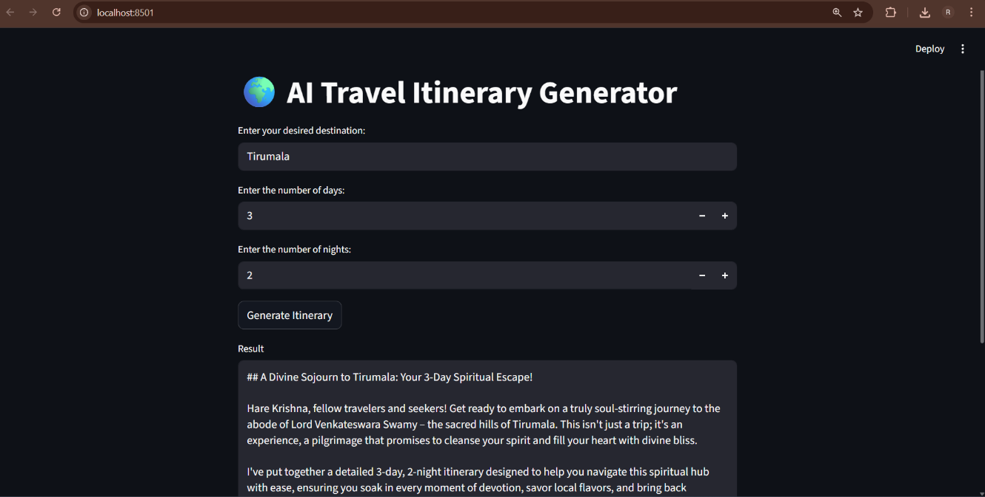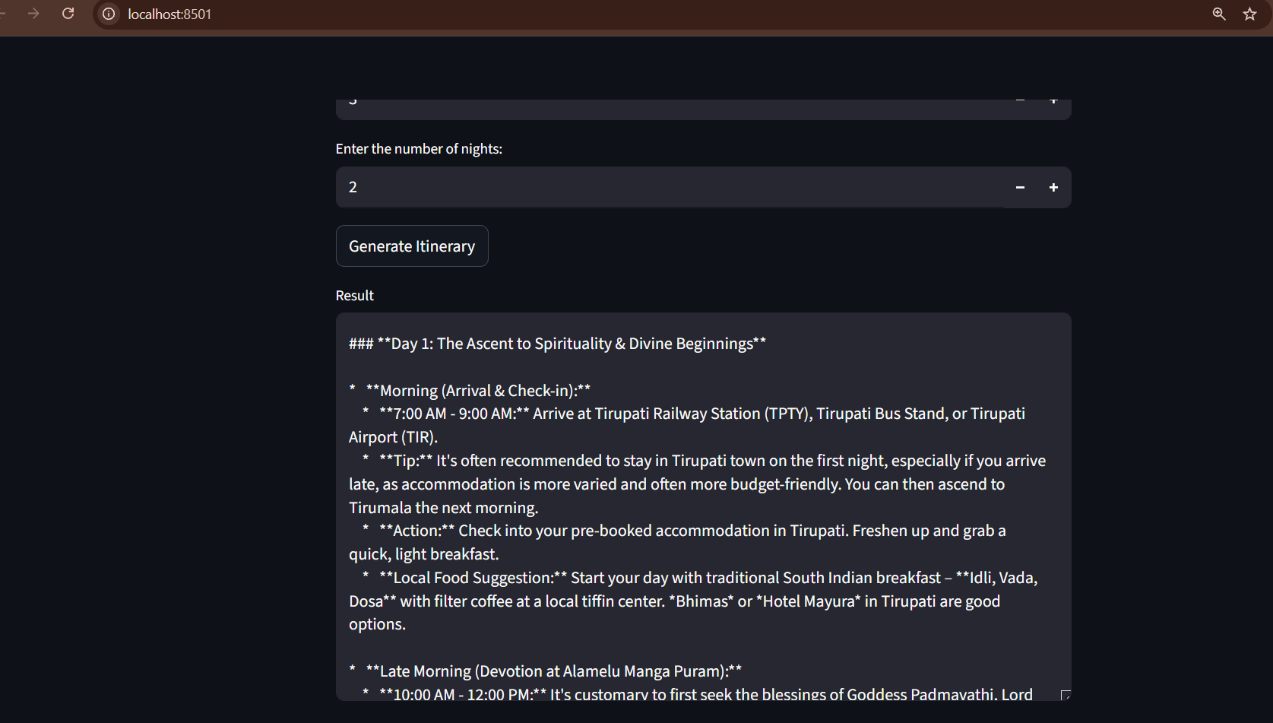
Deployment link: https://travel-itinerary-generator-3qfj.onrender.com
12. Known Issues
- AI responses may vary depending on prompt interpretation
- Internet dependency for cloud services
- Possible latency during peak usage
- Limited customization options in current version
13. Future Enhancements
- Multi-language support
- Voice-based interaction
- Mobile application integration
- Enhanced personalization models
- Real-time booking integrations
- Advanced recommendation analytics

